Setting up the Data Integration Framework on a new machine
By Calvin Luong
3/17/2022
Eclipse Installation
- Install installer from link below
https://www.eclipse.org/downloads/download.php?file=/oomph/epp/2021-12/R/eclipse-inst-jre-win64.exe
- Run the installer selecting the option shown below and follow the on-screen prompts
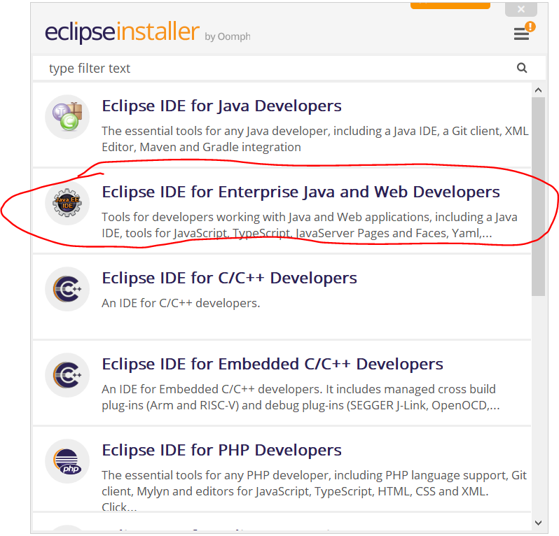
Setting up Subversion (SVN)
- Go to Help - Eclipse Marketplace
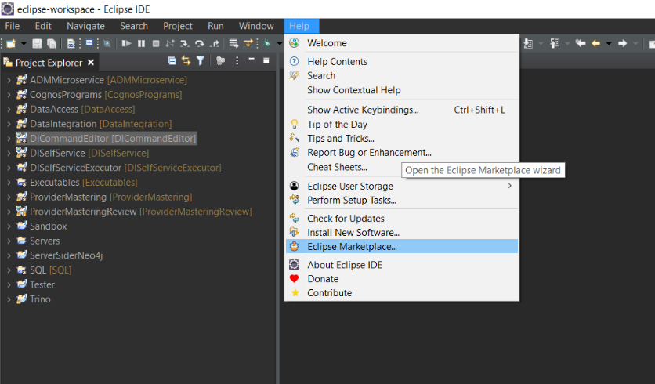

- Search for subclipse and install the plug-in shown below
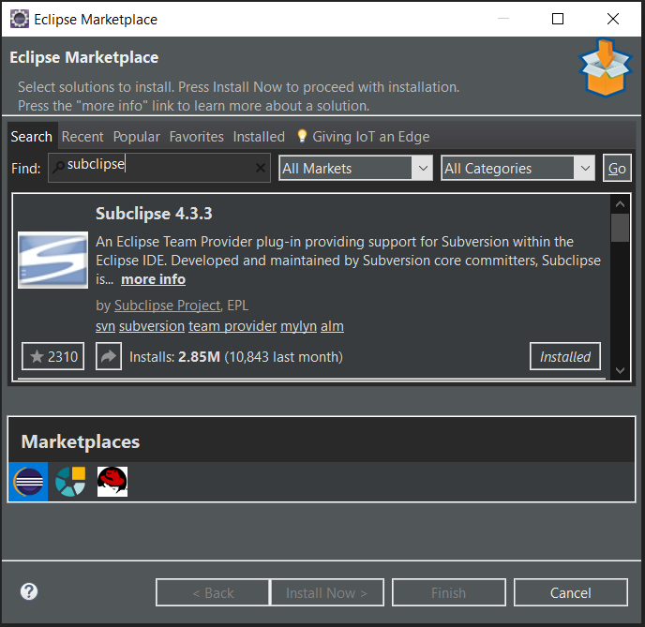

- Open the SVN perspective: Window -> Perspective -> Open Perspective -> Other…
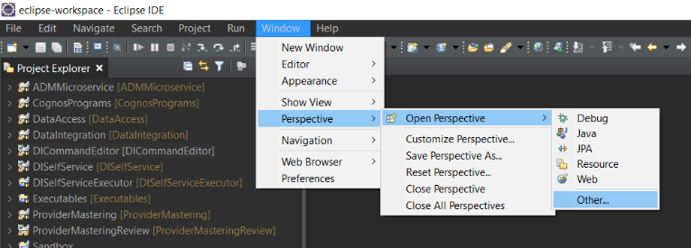

- Select SVN Repository Exploring
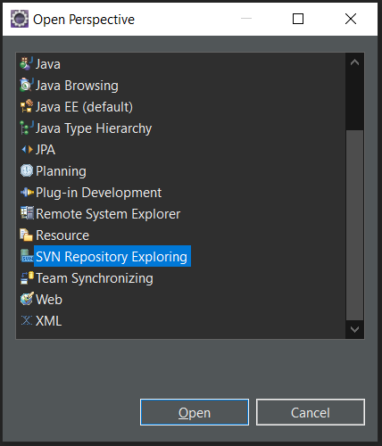
- In the SVN Repositories view: right click and select New -> Repository Location…
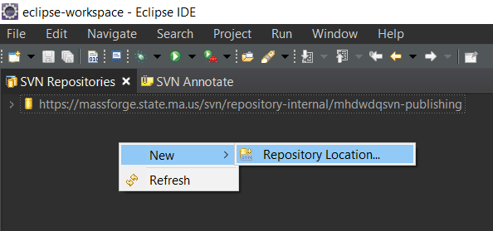

- Add https://massforge.state.ma.us/svn/repository-internal/mhdwdqsvn-publishing as a repository location and follow any proceeding prompts

- Check out any necessary projects: Right click -> Checkout…
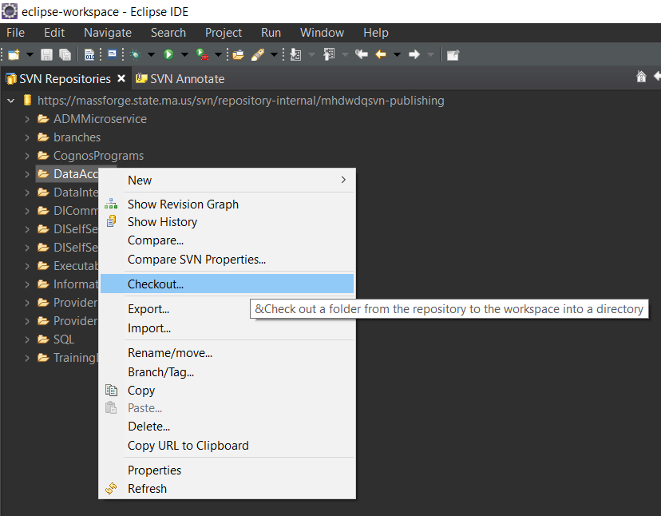

Setting up Tomcat
- Download Tomcat (64-bit) from the link below
https://tomcat.apache.org/download-90.cgi
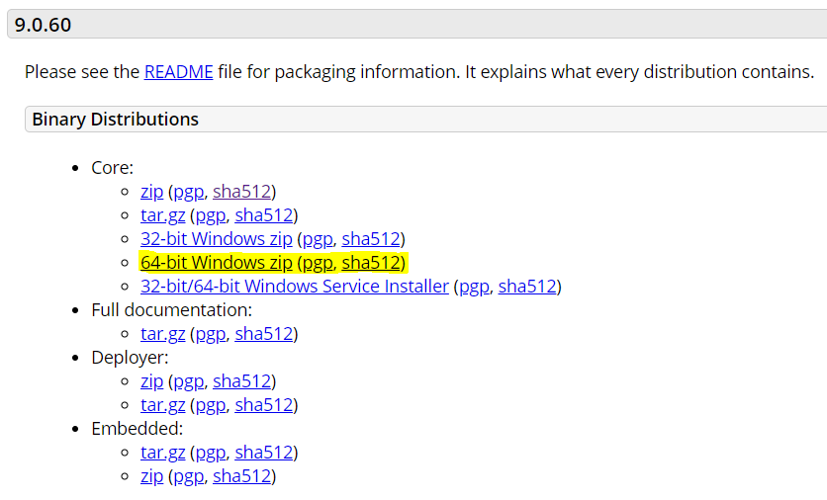
- Extract the zip

- Add a new Tomcat sever in eclipse

  - In the Servers view: right click -> new -> Server
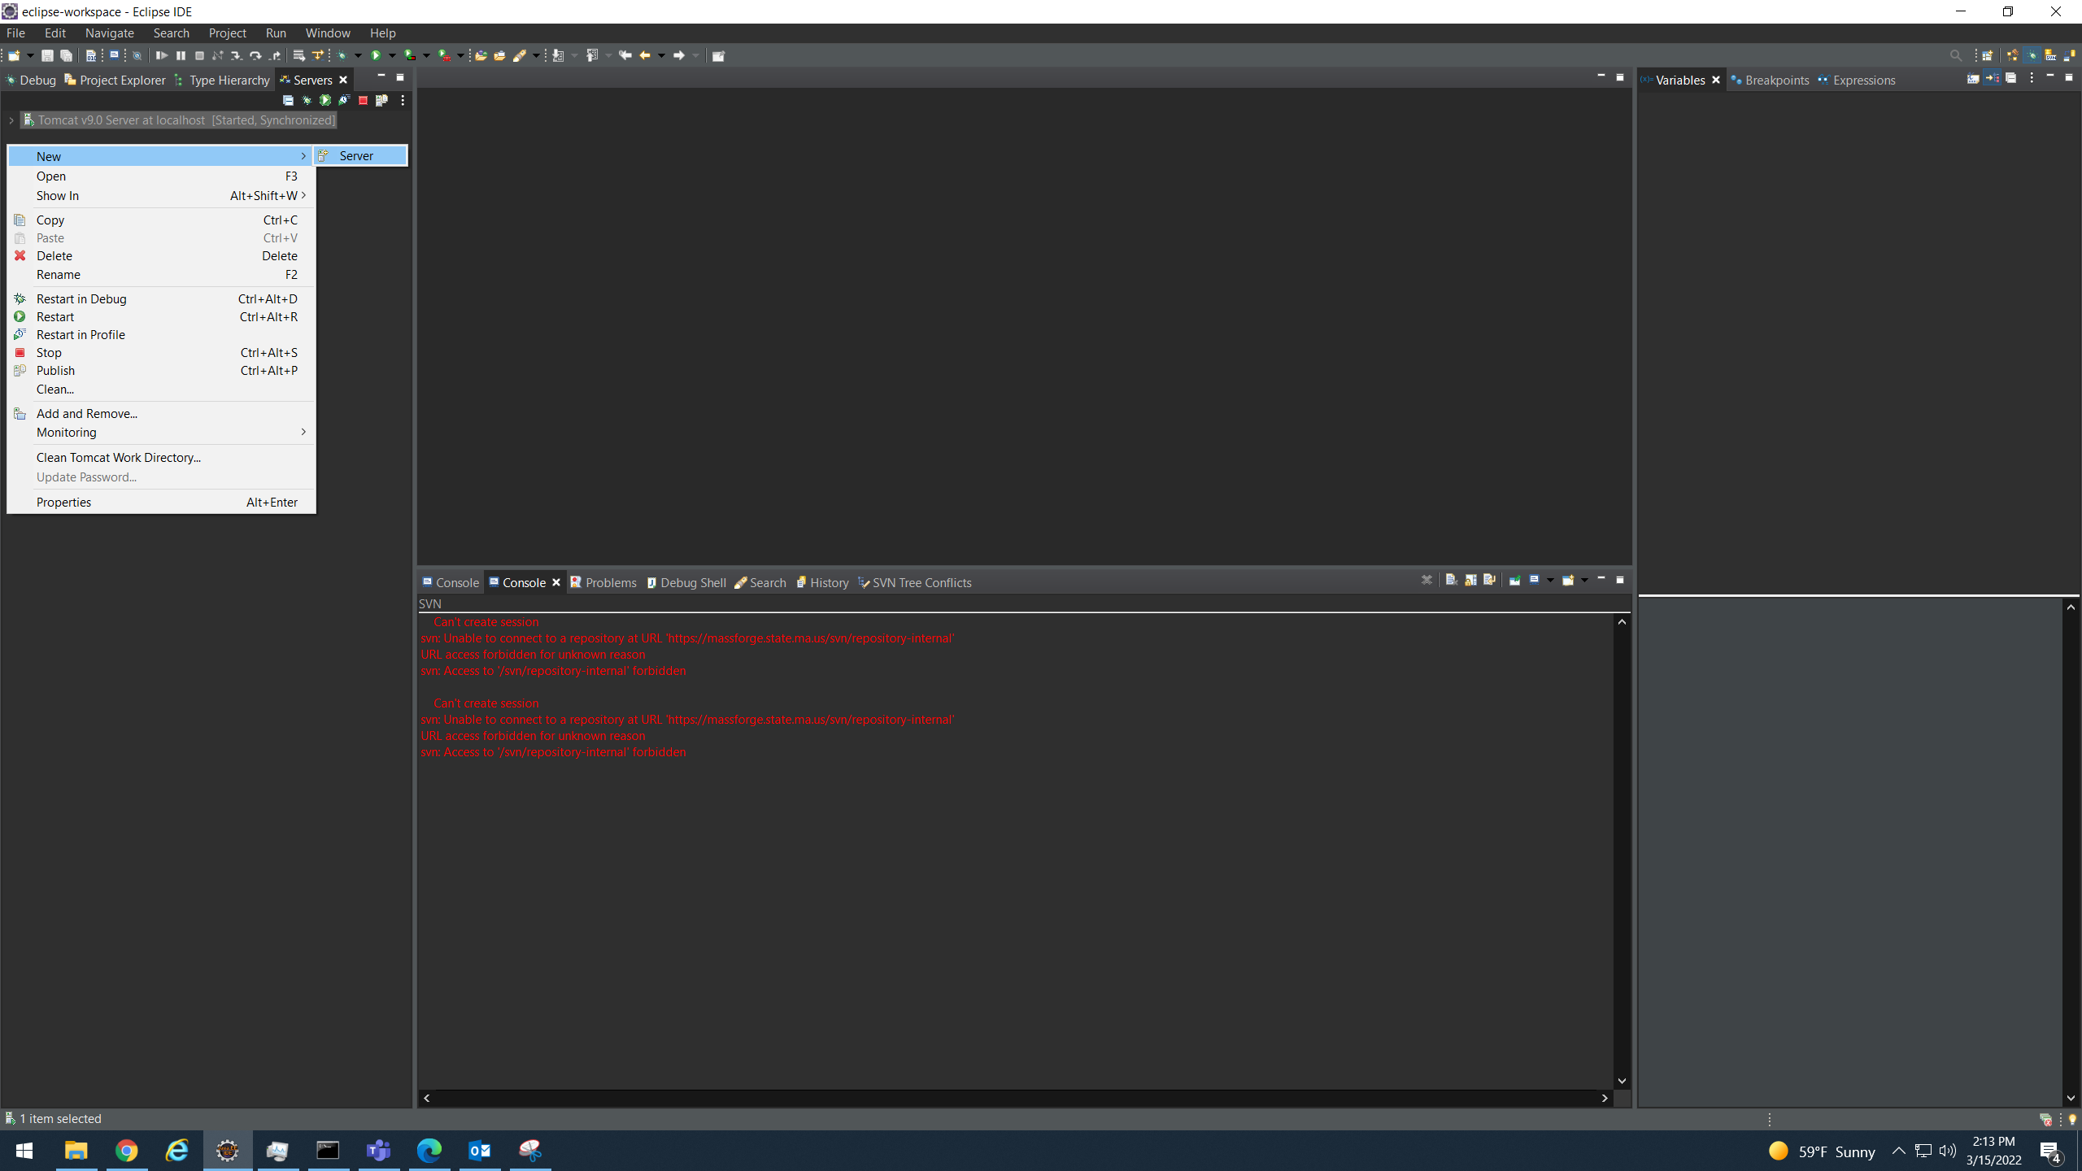

  - Select Tomcat v9.0 Server and click Add…
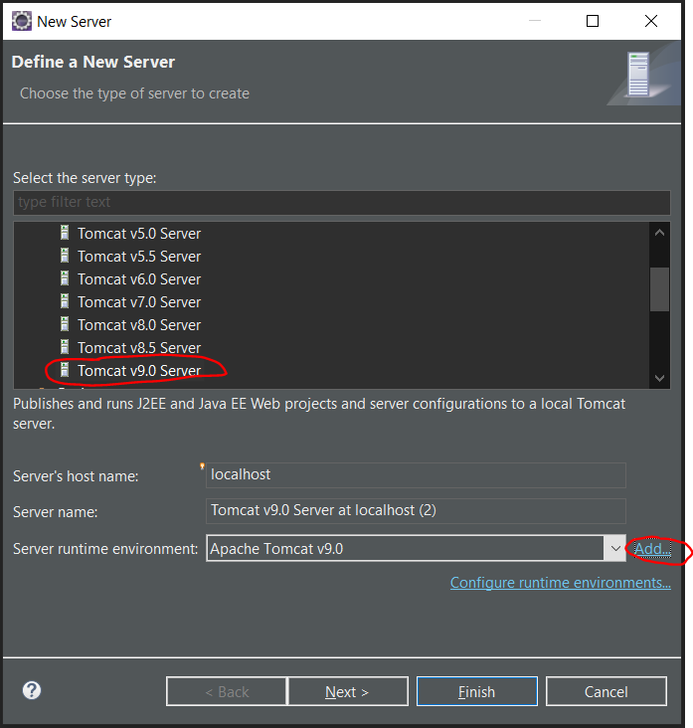
  - Enter Tomcat installation directory and select finish
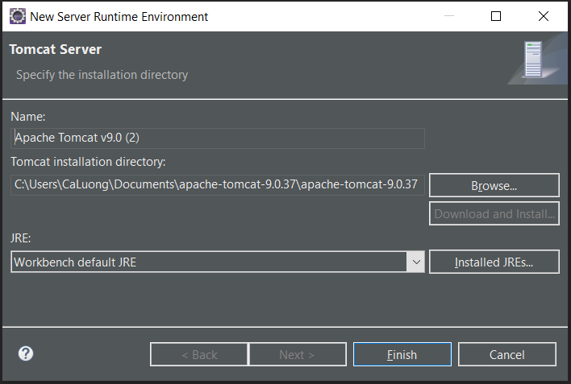

  - If Tomcat is having problems starting:
    - Double click the server in the Servers view
    - Check the properties circled below
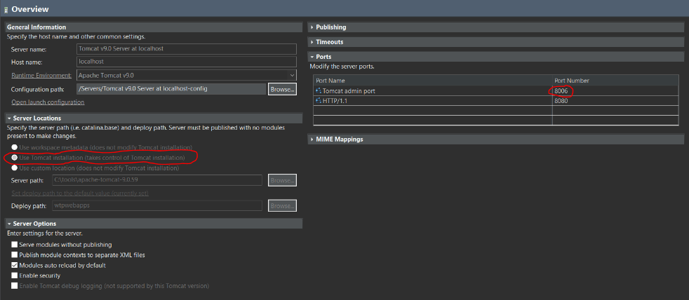

Configure Projects
- In Project Explorer -> right click project -> select Properties
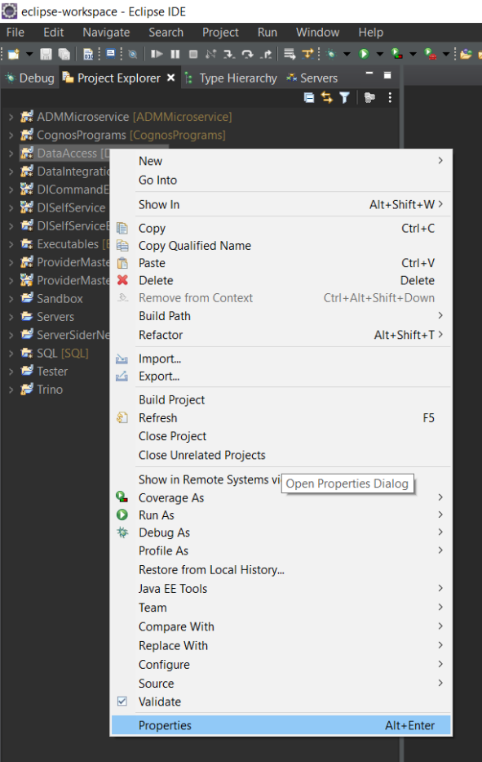

- The following steps differ for Java projects and Web applications and will be split into separate sections
For Java Projects
- Java Build Path
  - Add required projects
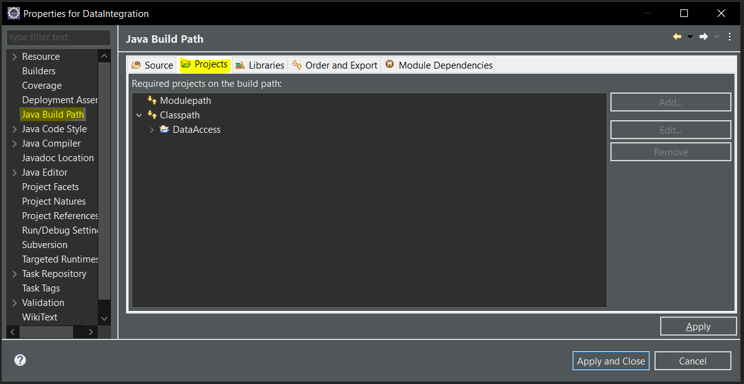
Note: This is an example and will differ depending on the project

  - Add required libraries and external jars (I have included screenshots showing the libraries and jars currently needed for the existing projects at the end of the document)
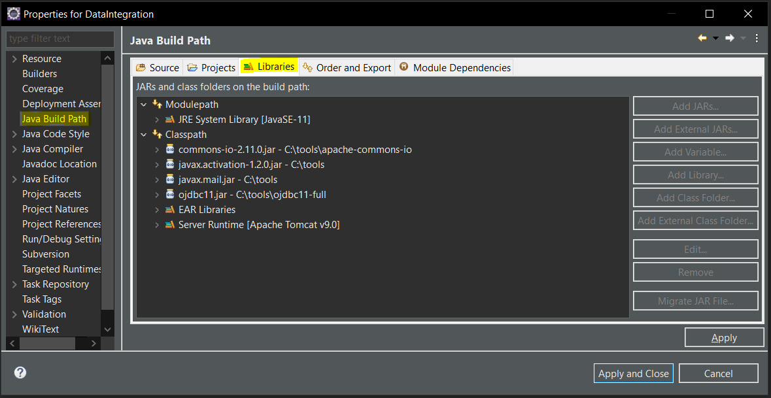
Note: This is an example and will differ depending on the project

- Deployment Assembly
  - Add required projects previously added to the build path
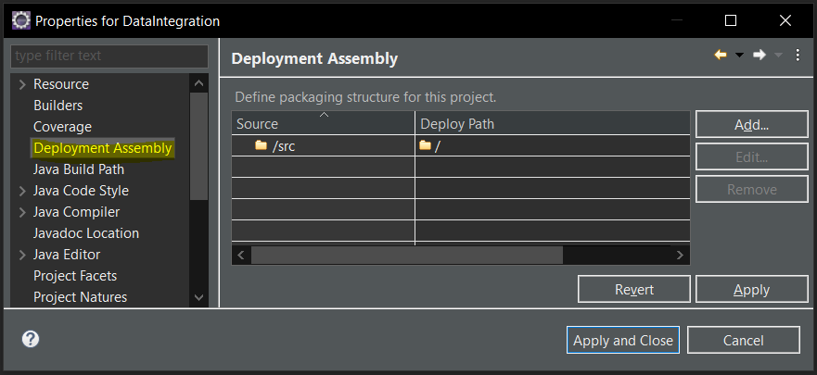
Note: This is an example and will differ depending on the project

- Project Facets
  - Select Java and Utility Module
    - Make sure that Java is set to the correct version
  - Select the Tomcat server under the Runtimes tab on the right
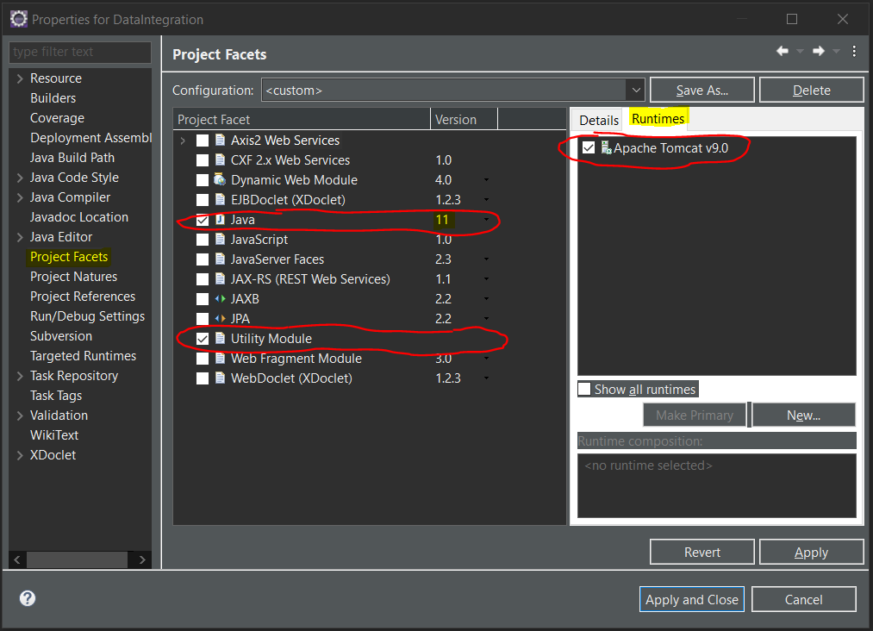
Note: This is an example and will differ depending on the project

For Web Applications
- Java Build Path
  - Add required projects
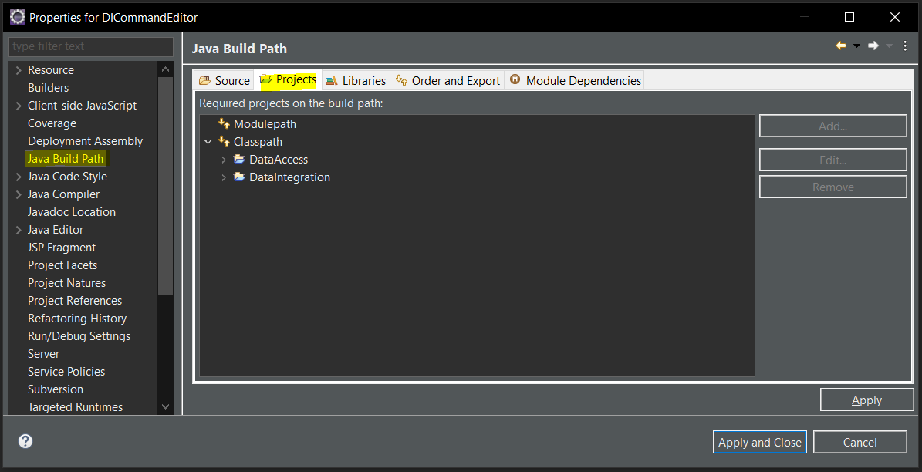
Note: This is an example and will differ depending on the project

  - Add required libraries and external jars
    - Make sure Web App Libraries is included
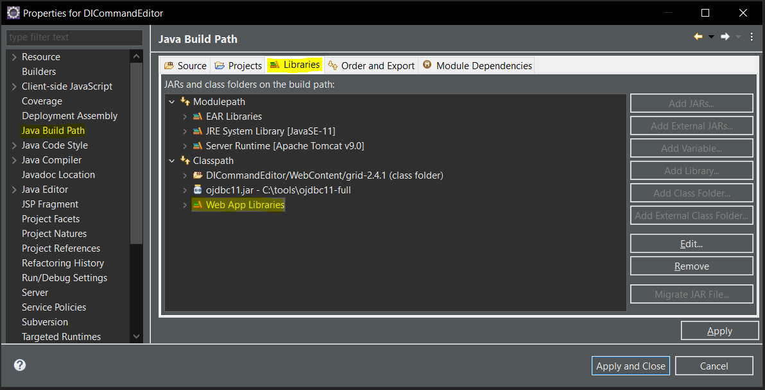
Note: This is an example and will differ depending on the project

- Deployment Assembly
  - Add required entries
    - The any Java packages needed for this project
    - The WebContent Folder
    - Any projects that were included in the build path
    - Any external jars that are not included in Web App Libraries
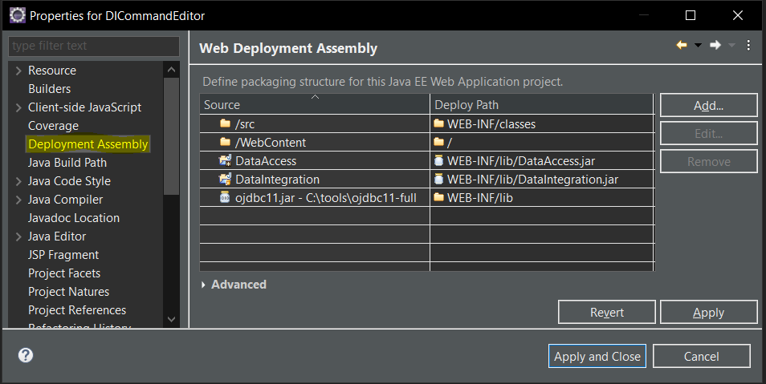
Note: This is an example and will differ depending on the project

- Project Facets
  - Select Java, JavaScript, and Dynamic Web Module for web applications
    - Make sure that Java is set to the correct version
  - Select Runtimes on the right and select the Tomcat server
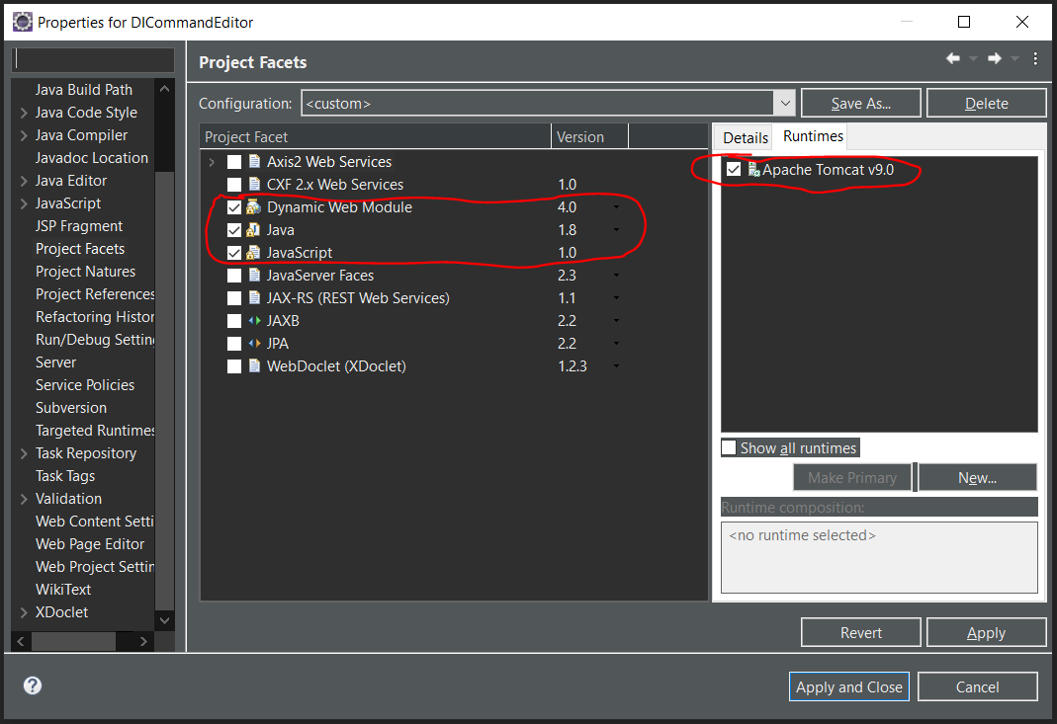
Note: This is an example and will differ depending on the project
Set Environment Variables (This section is currently a work in progress)
- Open Command Prompt

- Set environment variables below using setx command
- DATA_INTEGRATION_HOME
- TNS_ADMIN
- TNS_FOLDER

Syntax: setx <variable> <value>

Make sure all folder and file locations listed in DATA_INTEGRATION_CONTEXT for your Job Server are present including (note: some of these properties are not needed for all users, refer to the context table for the state of the art list):
- AwsCredentialsFolder
- DataFolder
- ExcelDataFolder
- ExcelExecutableFolder
- JarExportFolder
- MceInputFolder
- MceMatchFolder
- MceNonMatchFolder
- SFTP host private key
- VerboseFolder
- ZipExecutableFolder
These folders below are determined by the location of your eclipse workspace
- ExecutablesFolder
- OperationsExecutableFolder
- SqlFolder

Required libraries and jars
The jars in the following images can be found here:
\\170.154.117.14\File Services\Warehouse\Data_Warehouse_Project\DataQuality\libraries
- DataAccess
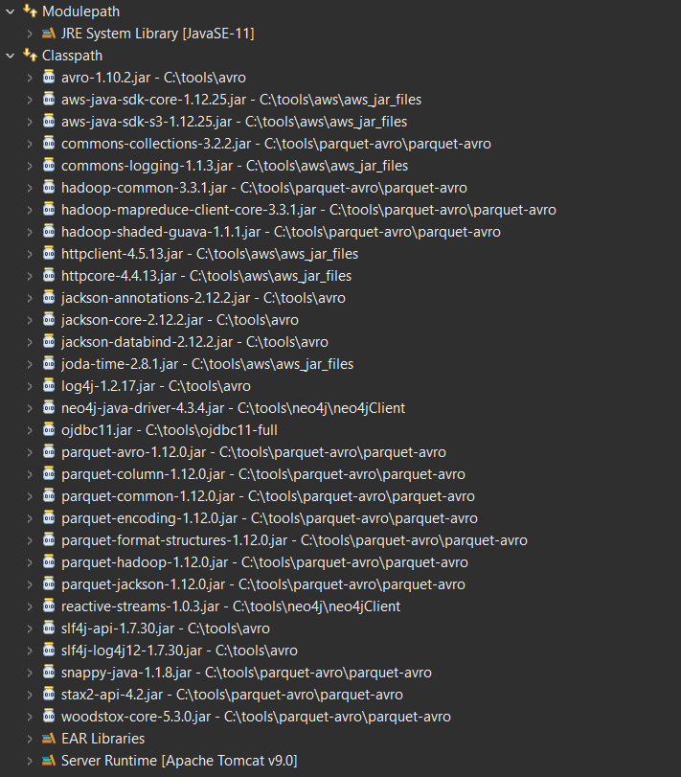

- DataIntegration
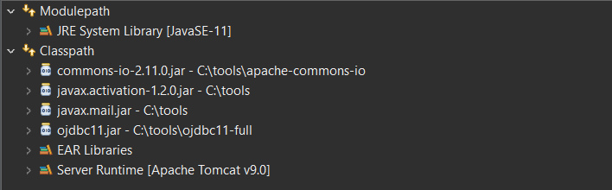

- DICommandEditor
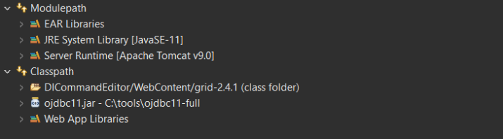

- DISelfService
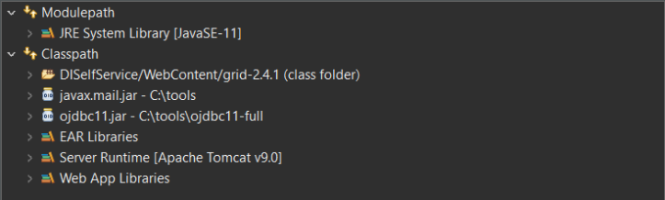

- ProviderMastering
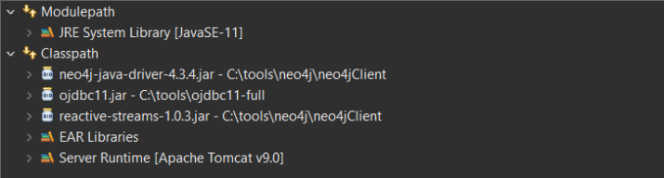

- ProviderMasteringReview
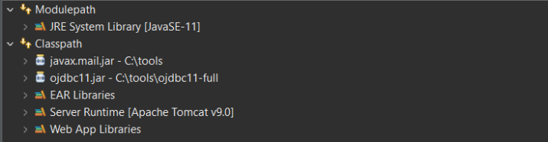

- ADMMicroService
